Kubernetes Task-04
- Deploy an application using a Deployment with 3 replicas and a rolling update strategy.

YAML Configuration

Create a file named **`nginx-deployment.yaml`**

apiVersion: apps/v1
kind: Deployment
metadata:
name: nginx-deployment
spec:
replicas: 3
strategy:
type: RollingUpdate
rollingUpdate:
maxUnavailable: 1
maxSurge: 1
selector:
matchLabels:
app: nginx
template:
metadata:
labels:
app: nginx
spec:
containers:
- name: nginx
image: nginx:1.21
ports:
- containerPort: 80

Step-by-Step Commands

Step 1: Create the YAML file

vi nginx-deployment.yaml

Paste the YAML configuration and save.
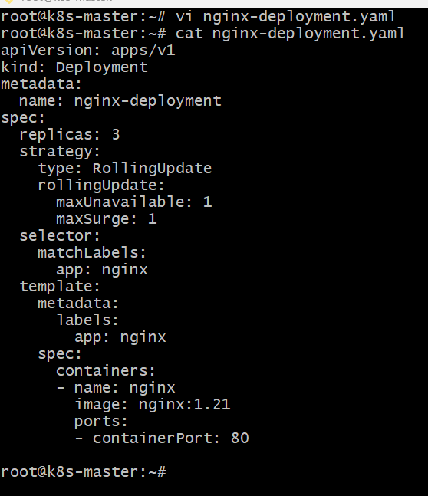
Step 2: Deploy the application

kubectl apply -f nginx-deployment.yaml
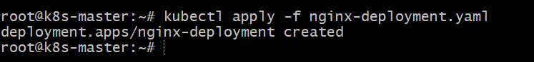
Step 3: Check the Deployment

kubectl get deployments
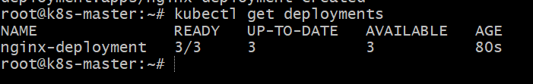
Step 4: Check the Pods created by the Deployment

kubectl get pods

Expected output should show 3 running pods.
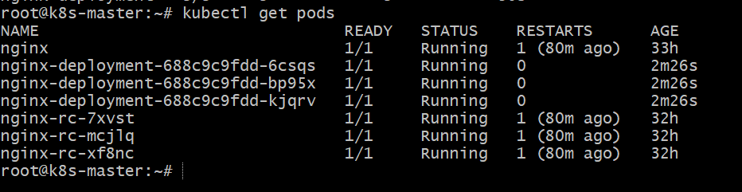
Step 5: View detailed Deployment information

kubectl describe deployment nginx-deployment

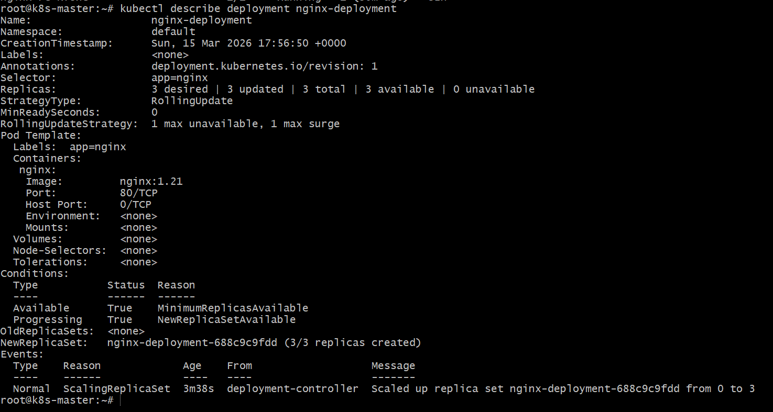
Verification Steps

Verify rollout status

kubectl rollout status deployment nginx-deployment

- Expected output:
deployment "nginx-deployment" successfully rolled out

Verify Deployment details

kubectl get deployment nginx-deployment -o wide

- Conclusion

The Deployment was successfully created with 3 replicas of the Nginx application.
The RollingUpdate strategy ensures that updates to the application occur gradually without downtime, by replacing old pods with new ones one at a time while maintaining availability.

- Configure a Deployment with a Recreate strategy and observe the downtime.

YAML Configuration

apiVersion: apps/v1
kind: Deployment
metadata:
name: nginx-recreate
spec:
replicas: 3
strategy:
type: Recreate
selector:
matchLabels:
app: nginx-recreate
template:
metadata:
labels:
app: nginx-recreate
spec:
containers:
- name: nginx
image: nginx:1.21
ports:
- containerPort: 80

Explanation of Important Attributes

| Attribute | Purpose |
| ----------------------- | ------------------------------------------------------------------- --------------------- |
| **replicas: 3** | Runs 3 pods of the application |
| **strategy: Recreate** | Deletes all old pods first, then creates new ones (causes downtime) |
| **selector.matchLabels** | Tells the deployment which pods it manages |
| **template.labels** | Labels applied to pods so the deployment can identify them |

Step-by-Step Commands

Step 1: Create YAML file

vi nginx-recreate.yaml

Step 2: Create the Deployment

kubectl apply -f nginx-recreate.yaml

Creates the deployment with 3 pods.

Step 3: Check pods

kubectl get pods

Verifies that 3 pods are running.
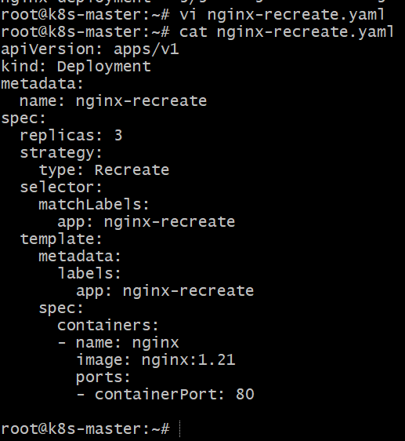
Step 4: Trigger update (to observe recreate)

kubectl set image deployment/nginx-recreate nginx=nginx:1.25

Updates image → Kubernetes deletes old pods first.
Step 5: Watch pods

kubectl get pods -w

You will briefly see **0 pods**, showing downtime.

Verification Steps

kubectl get deployment

kubectl rollout status deployment nginx-recreate

kubectl get pods

Confirm **3 new pods running with updated image**.
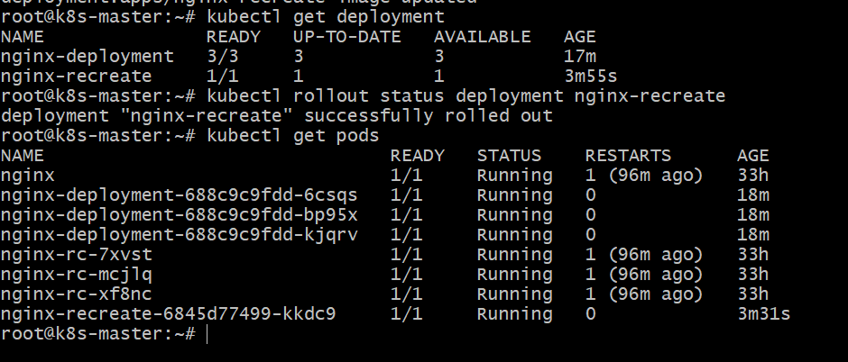
- Conclusion

A Deployment was created with 3 replicas using the Recreate strategy.
During the update, Kubernetes terminated all existing pods before creating new ones, causing temporary downtime, which demonstrates how the Recreate deployment strategy works.

- Update an existing Deployment and perform a rollback to the previous version.

YAML Configuration (Initial Deployment)

vi nginx-rollback.yaml

apiVersion: apps/v1
kind: Deployment
metadata:
name: nginx-rollback
spec:
replicas: 3
selector:
matchLabels:
app: nginx-demo
template:
metadata:
labels:
app: nginx-demo
spec:
containers:
- name: nginx
image: nginx:1.21
ports:
- containerPort: 80

Explanation of Important Attributes

| Attribute | Purpose |
| ------------------------ | --------------------------------------- |
| **replicas: 3** | Runs 3 pods of the application |
| **image: nginx:1.21** | Initial version of the application |
| **selector.matchLabels** | Deployment manages pods with this label |
| **template.labels** | Labels assigned to pods |
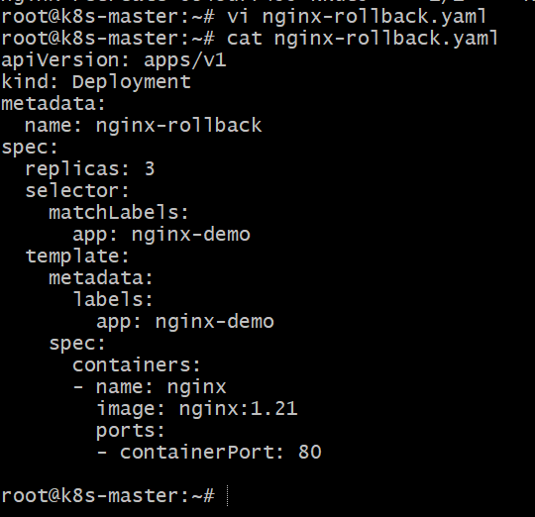
Step-by-Step Commands
Step 1: Create Deployment

kubectl apply -f nginx-rollback.yaml

Creates deployment with **3 nginx pods**.
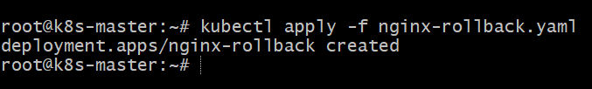
Step 2: Verify Deployment

kubectl get deployments
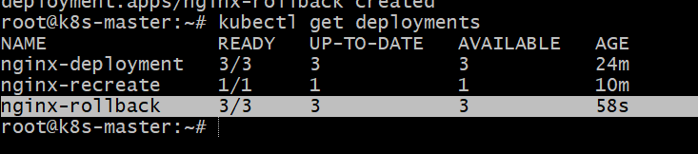

kubectl get pods

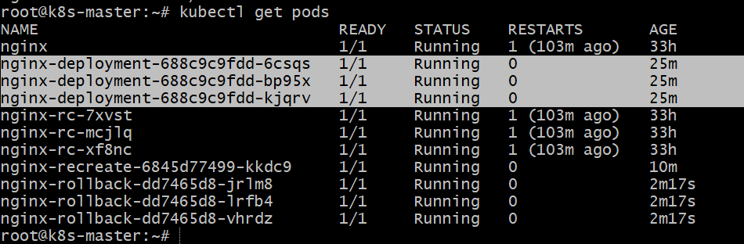
Step 3: Update the Deployment (New Version)

kubectl set image deployment/nginx-rollback nginx=nginx:1.25

Updates container image to a new version.
Step 4: Check Rollout Status

kubectl rollout status deployment nginx-rollback

Step 5: Check Rollout History

kubectl rollout history deployment nginx-rollback

Shows previous versions of deployment.

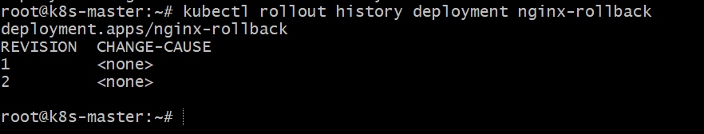
Step 6: Rollback to Previous Version

kubectl rollout undo deployment nginx-rollback

Restores the previous working version (nginx:1.21).
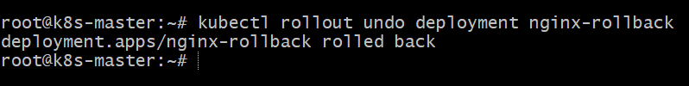
Verification Steps

Check deployment

kubectl describe deployment nginx-rollback
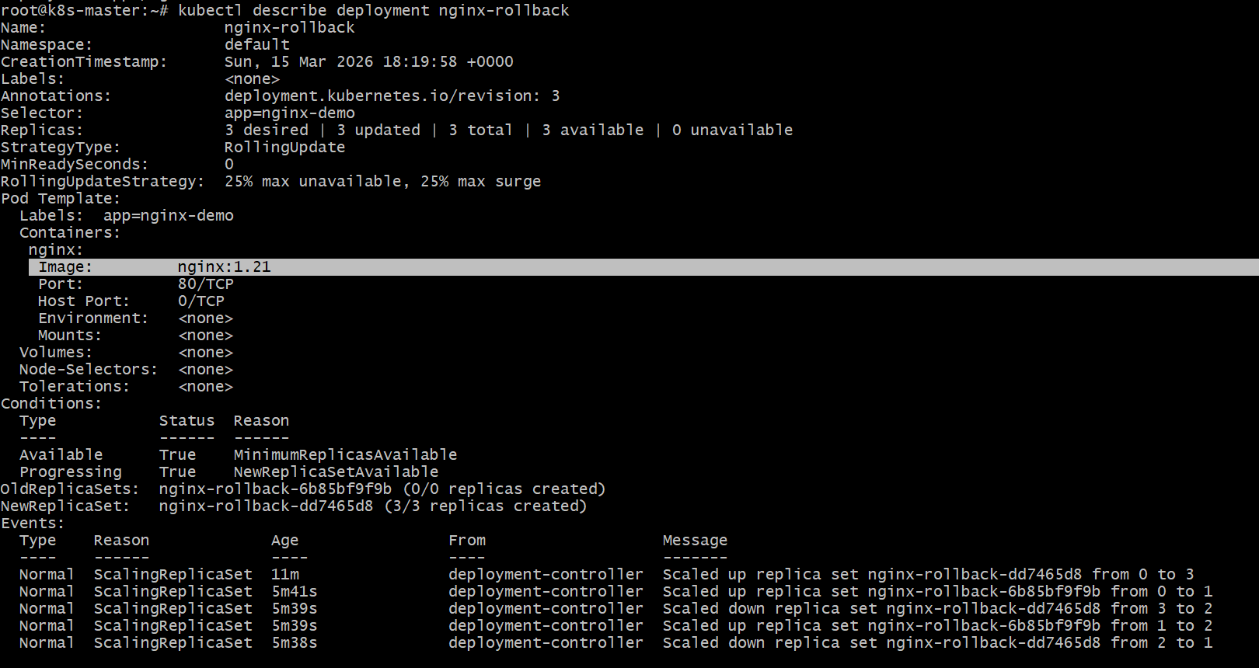
Check pods

kubectl get pods
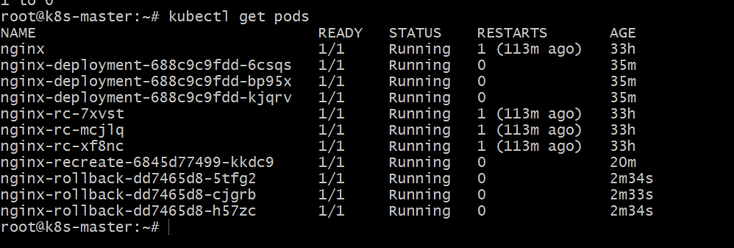
Check rollout history again

kubectl rollout history deployment nginx-rollback
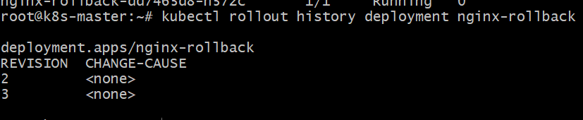
- Conclusion

An existing Deployment was updated with a new image version.
Using kubectl rollout undo, Kubernetes rolled back the deployment to the previous stable version, demonstrating the rollback capability of Deployments for safe application updates.

- Modify a Deployment to add resource requests and limits for CPU and memory.

YAML Configuration

apiVersion: apps/v1
kind: Deployment
metadata:
name: nginx-resources
spec:
replicas: 3
selector:
matchLabels:
app: nginx-res
template:
metadata:
labels:
app: nginx-res
spec:
containers:
- name: nginx
image: nginx:1.21
resources:
requests:
cpu: "200m"
memory: "128Mi"
limits:
cpu: "500m"
memory: "256Mi"
ports:
- containerPort: 80

Explanation of Important Attributes

| Attribute | Purpose |
| --------------------- | ----------------------------------------------------------------------- |
| resources | Defines CPU and memory allocation for the container |
| requests | Minimum resources guaranteed for the container |
| limits | Maximum resources the container can use |
| cpu: 200m | Requests 0.2 CPU core |
| memory: 128Mi | Requests 128MB memory |

Step-by-Step Commands

Step 1: Create or modify YAML

vi nginx-resources.yaml
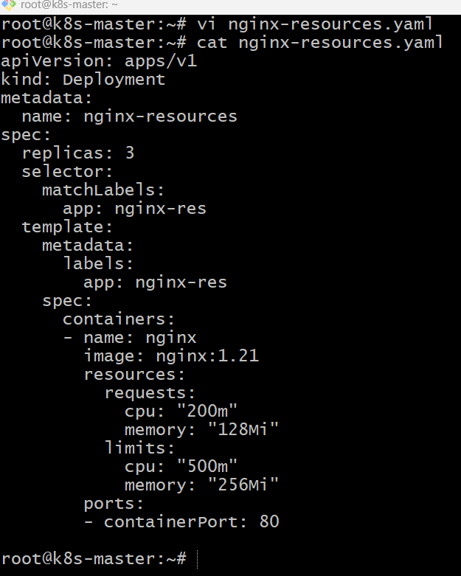
Step 2: Apply the Deployment

kubectl apply -f nginx-resources.yaml

Creates or updates deployment with resource limits
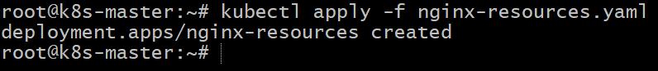
Step 3: Check Deployment

kubectl get deployments
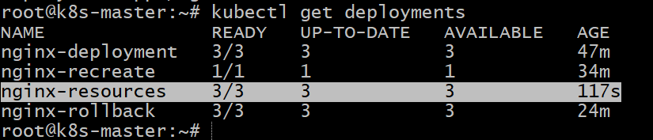
Step 4: Check Pods

kubectl get pods

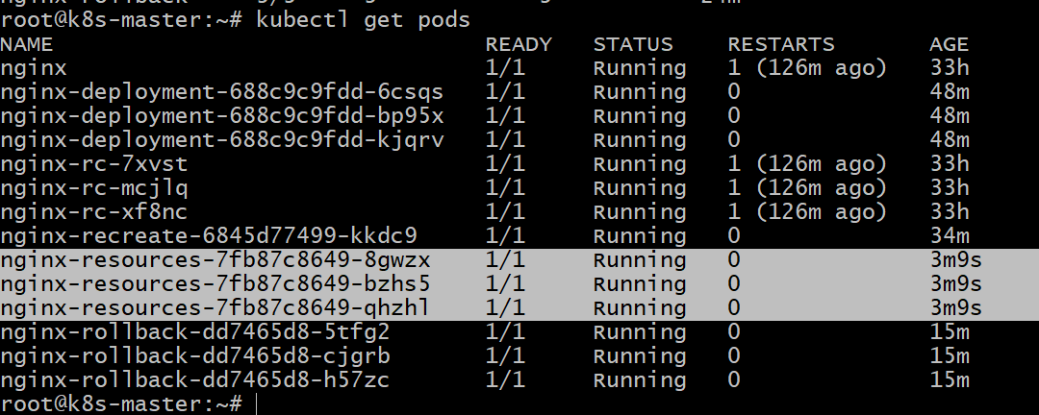
Verification Steps

Check resource configuration

kubectl describe deployment nginx-resources
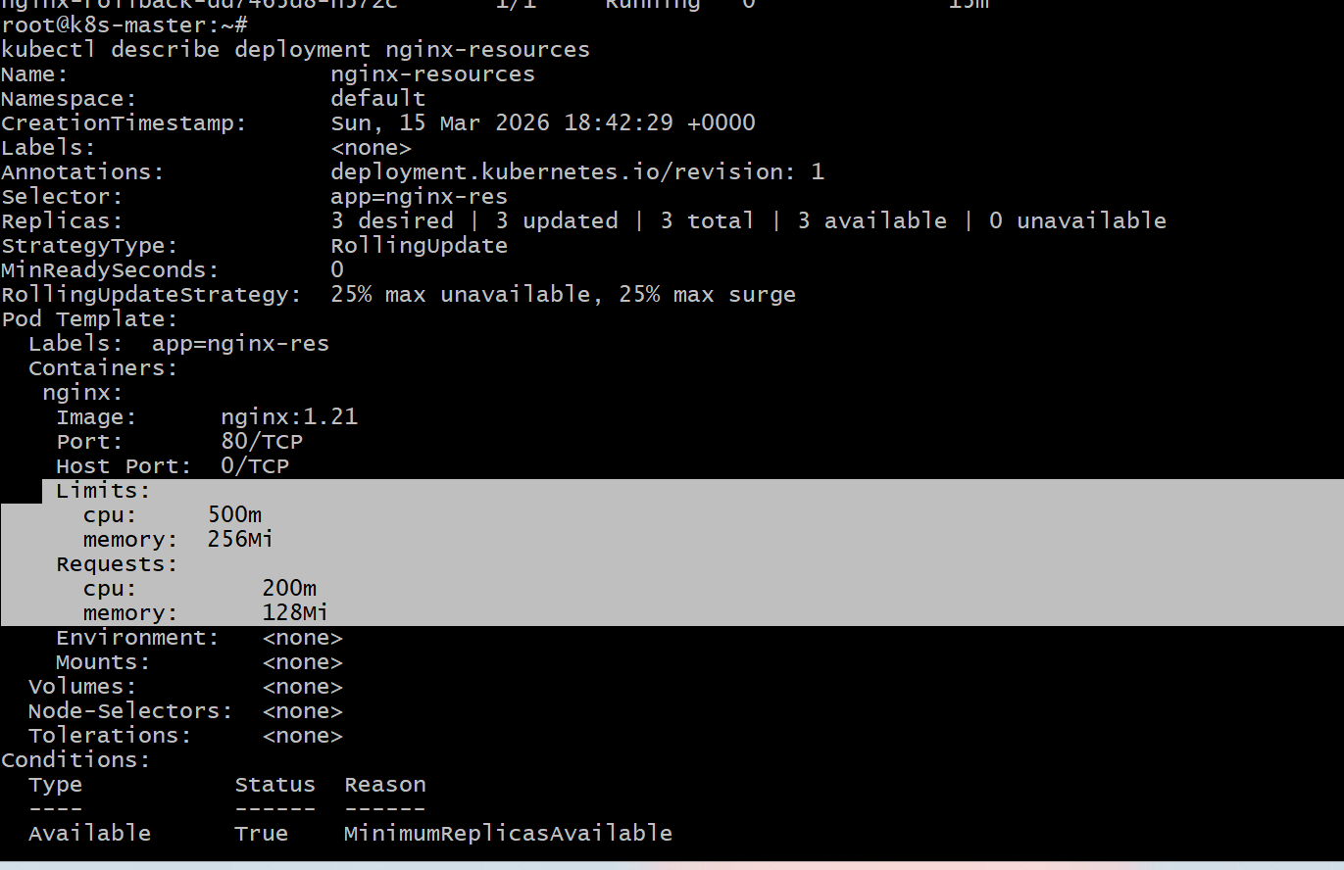
Check pod resource limits

kubectl describe pod <pod-name>
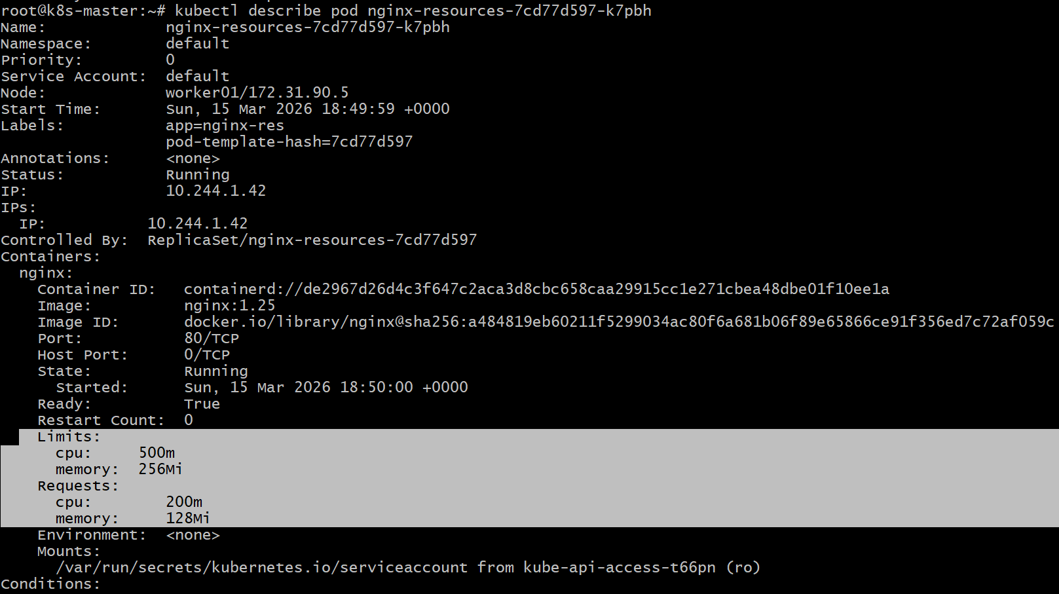

- Conclusion

The Deployment was modified to include CPU and memory requests and limits.
This ensures the container receives guaranteed minimum resources while preventing it from exceeding defined limits, improving cluster resource management and stability.

- Create a Deployment with MaxSurge and MaxUnavailable configurations.

YAML Configuration

apiVersion: apps/v1
kind: Deployment
metadata:
name: nginx-rolling
spec:
replicas: 3
strategy:
type: RollingUpdate
rollingUpdate:
maxSurge: 1
maxUnavailable: 1
selector:
matchLabels:
app: nginx-roll
template:
metadata:
labels:
app: nginx-roll
spec:
containers:
- name: nginx
image: nginx:1.21
ports:
- containerPort: 80

Explanation of Important Attributes

| Attribute | Purpose |
| ------------------------------- | --------------------------------------------------------------------------- |
| strategy: RollingUpdate | Updates pods gradually without downtime |
| maxSurge: 1 | Allows 1 extra pod above desired replicas during update |
| maxUnavailable: 1 | Allows 1 pod to be unavailable during update |
| replicas: 3 | Desired number of running pods |

Example during update:
Pods can temporarily become **4 running pods (3 + 1 surge)**.

Step-by-Step Commands

Step 1: Create YAML

vi nginx-rollingupdate.yaml
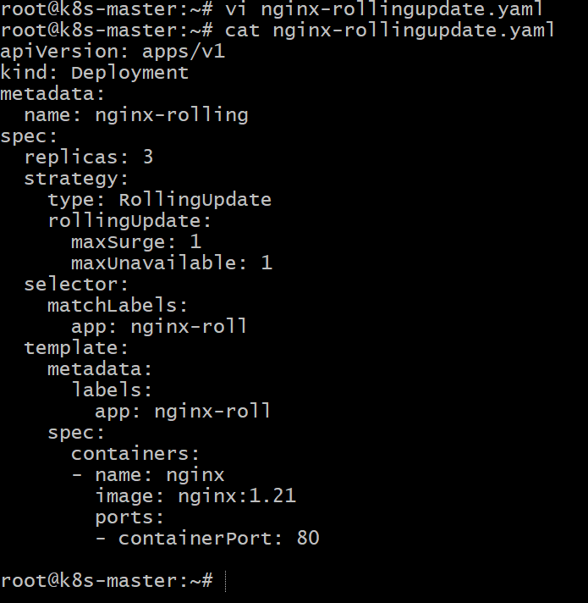
Step 2: Create Deployment

kubectl apply -f nginx-rollingupdate.yaml

Step 3: Check Deployment

kubectl get deployments

Step 4: Check Pods

kubectl get pods
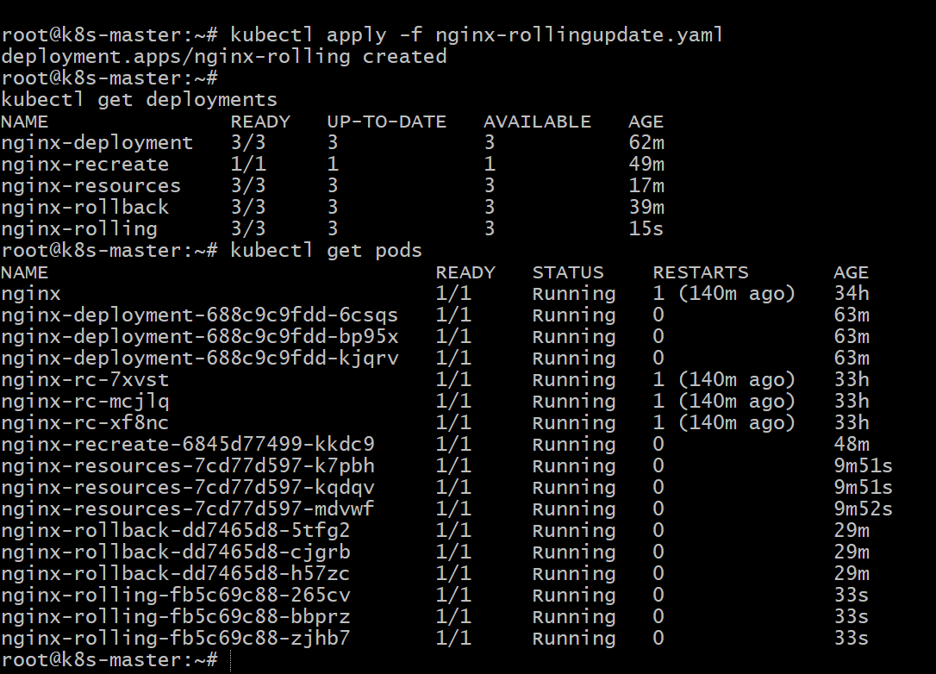

Step 5: Trigger an Update

kubectl set image deployment/nginx-rolling nginx=nginx:1.25
Watch rolling update:

kubectl get pods
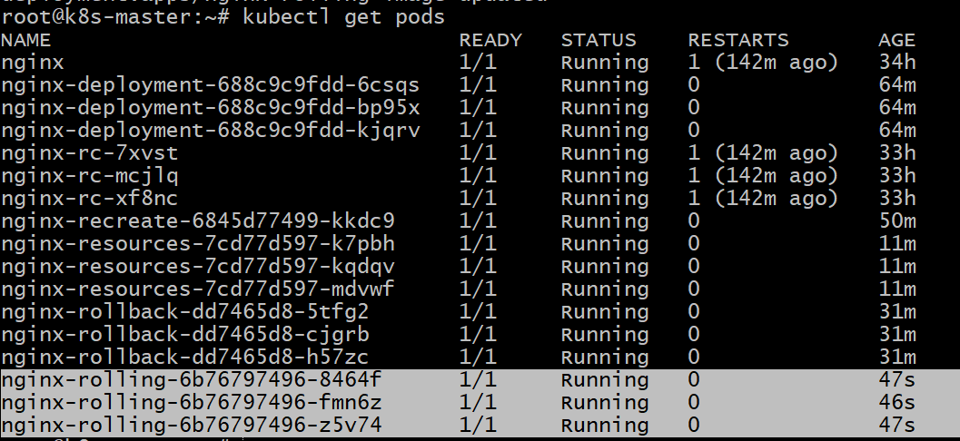
Verification Steps

Check rollout status

kubectl rollout status deployment nginx-rolling

Check deployment details

kubectl describe deployment nginx-rolling
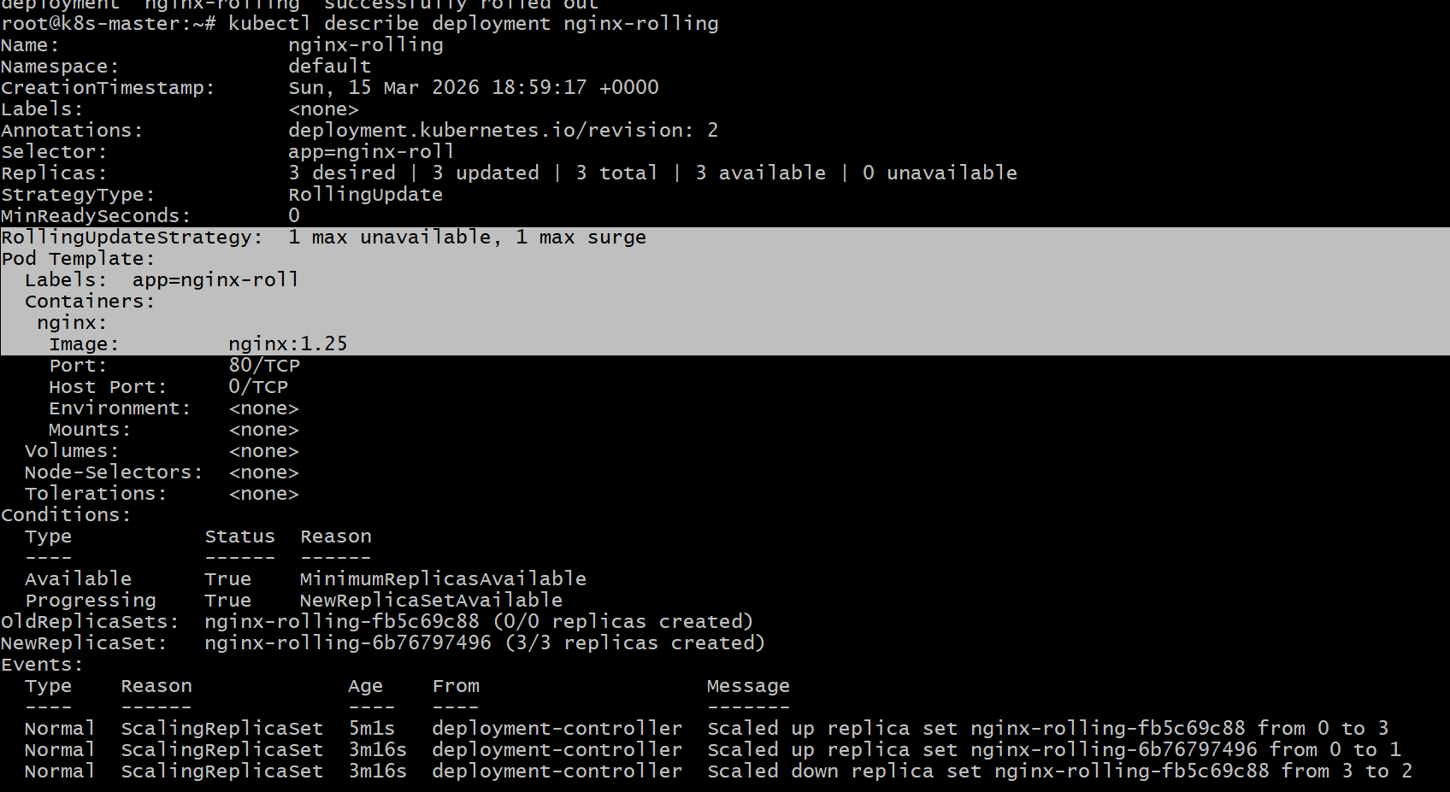

- Conclusion

A Deployment was created using the RollingUpdate strategy with MaxSurge=1 and MaxUnavailable=1.
This ensures the application updates gradually with minimal downtime, while temporarily allowing extra pods during the update process.

- Set up a Deployment with a custom revision history limit.

YAML Configuration

apiVersion: apps/v1
kind: Deployment
metadata:
name: nginx-revision
spec:
replicas: 3
revisionHistoryLimit: 5
selector:
matchLabels:
app: nginx-rev
template:
metadata:
labels:
app: nginx-rev
spec:
containers:
- name: nginx
image: nginx:1.21
ports:
- containerPort: 80

Explanation of Important Attributes

| Attribute | Purpose |
| --------------------------- | ------------------------------------------------------- |
| replicas: 3 | Runs 3 pods |
| revisionHistoryLimit: 5 | Kubernetes stores only the last 5 rollout revisions |
| selector.matchLabels | Identifies pods managed by the deployment |

This helps control how many old ReplicaSets are stored for rollback.

Step-by-Step Commands

Step 1: Create YAML file

vi nginx-revision.yaml
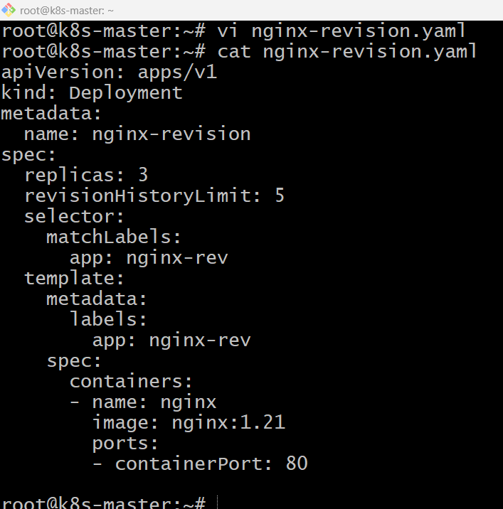
Step 2: Create Deployment

kubectl apply -f nginx-revision.yaml

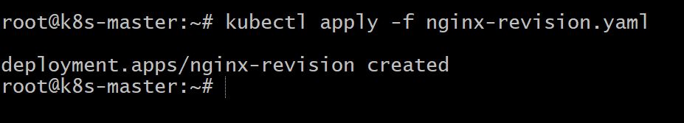
Step 3: Check Deployment

kubectl get deployments

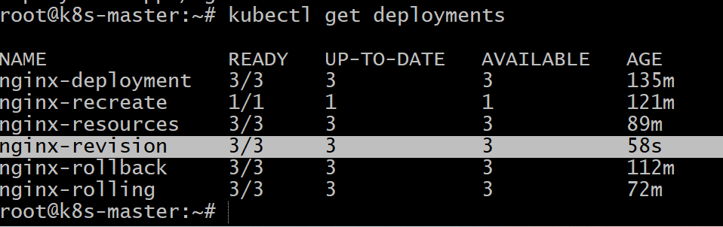
Step 4: Update deployment to create revisions

kubectl set image deployment/nginx-revision nginx=nginx:1.25
Verification Steps

Check rollout history

kubectl rollout history deployment nginx-revision

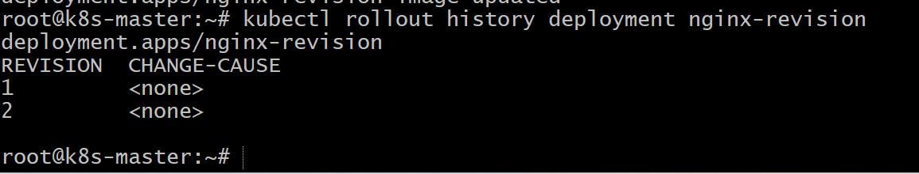
Check ReplicaSets stored

kubectl get rs

You should see only the last 5 revisions kept.
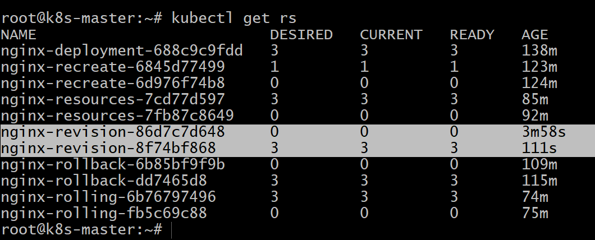

- Conclusion

A Deployment was created with a custom revisionHistoryLimit of 5.
Kubernetes will store only the last 5 rollout revisions, helping reduce unused ReplicaSets while still allowing rollback to recent versions.

- Pause a Deployment during an update and then resume it.

YAML Configuration

vi nginx-pause.yaml

apiVersion: apps/v1
kind: Deployment
metadata:
name: nginx-pause
spec:
replicas: 3
selector:
matchLabels:
app: nginx-pause
template:
metadata:
labels:
app: nginx-pause
spec:
containers:
- name: nginx
image: nginx:1.21
ports:
- containerPort: 80

Explanation of Important Attributes

| Attribute | Purpose |
| ------------------------ | --------------------------------------------- |
| replicas: 3 | Runs 3 pods |
| image: nginx:1.21 | Initial container version |
| selector & labels | Connect deployment with its pods |

(Deployment pause/resume is handled through **kubectl commands**, not YAML.)
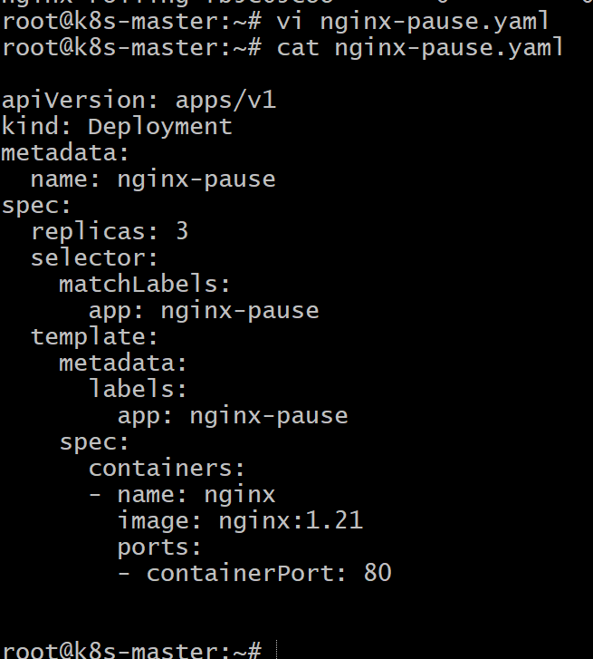
Step-by-Step Commands

Step 1: Create Deployment

kubectl apply -f nginx-pause.yaml
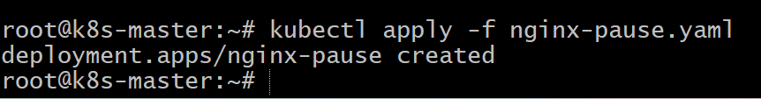
Step 2: Pause the Deployment

kubectl rollout pause deployment nginx-pause

Stops rollout updates temporarily.
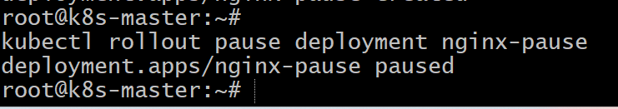
Step 3: Update the Deployment

kubectl set image deployment/nginx-pause nginx=nginx:1.25

Update is recorded but not applied because deployment is paused.

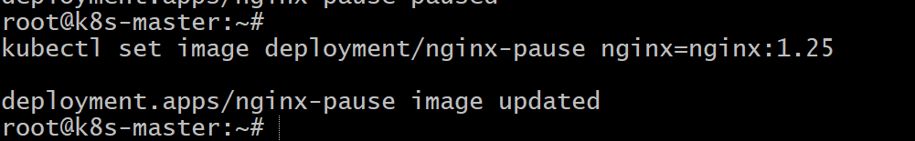
Step 4: Check Deployment

kubectl get deployments
Kubectl get pods
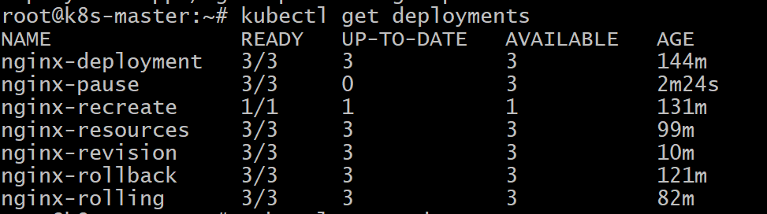

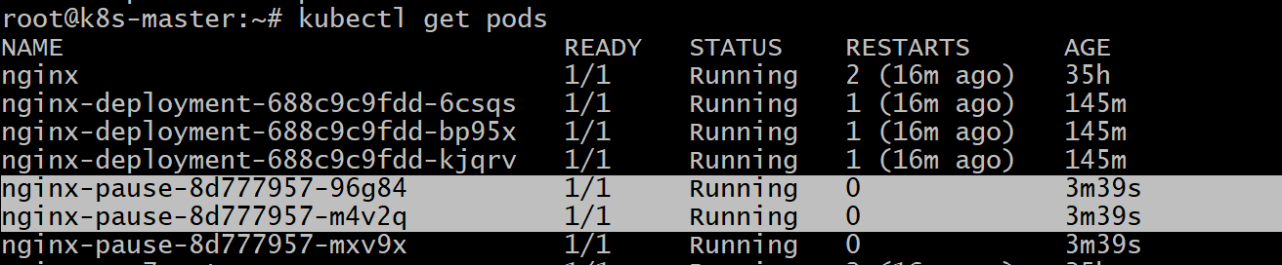

Step 5: Resume the Deployment

kubectl rollout resume deployment nginx-pause

Rollout continues and updates the pods.
Verification Steps

Check rollout status

kubectl rollout status deployment nginx-pause

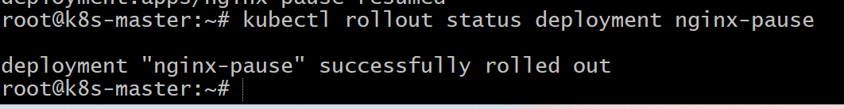
Check pods

kubectl get pods
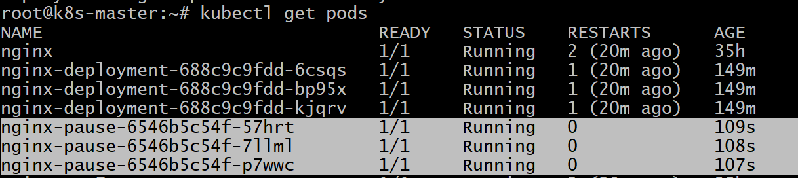
Verify image version

kubectl describe deployment nginx-pause
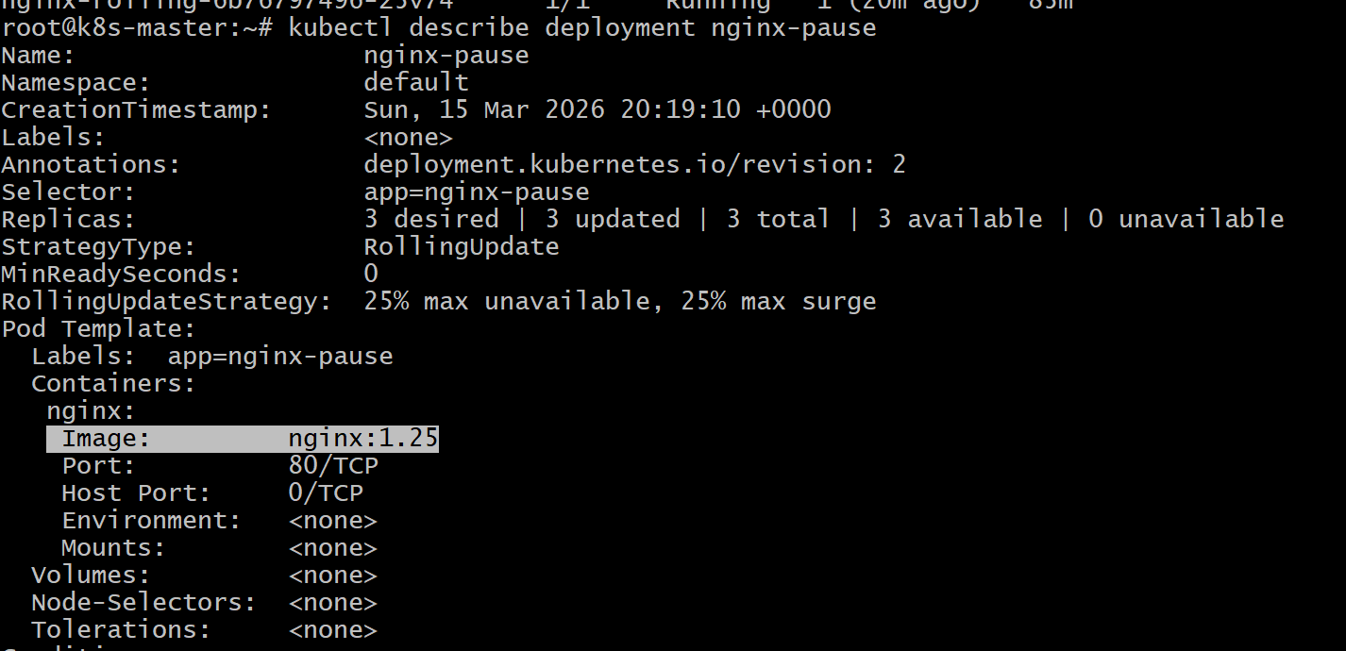

- Conclusion
The Deployment rollout was paused during an update, preventing the new version from being deployed immediately.
After running resume, Kubernetes continued the rollout and updated the pods successfully. This feature is useful for reviewing or batching multiple changes before applying them.

- Create a pod using resource requests for memory and CPU and observe how the scheduler assigns it to a node.

YAML Configuration

apiVersion: v1
kind: Pod
metadata:
name: resource-pod
spec:
containers:
- name: nginx
image: nginx:1.21
resources:
requests:
cpu: "250m"
memory: "128Mi"
ports:
- containerPort: 80

Explanation of Important Attributes

| Attribute | Purpose |
| ------------------------- | ----------------------------------------------------------------- |
| resources.requests | Minimum CPU and memory required for the pod |
| cpu: 250m | Requests 0.25 CPU core |
| memory: 128Mi | Requests 128 MB memory |

The Kubernetes scheduler uses these requests to decide which node has enough resources to run the pod.

Step-by-Step Commands

Step 1: Create YAML file

vi resource-pod.yaml
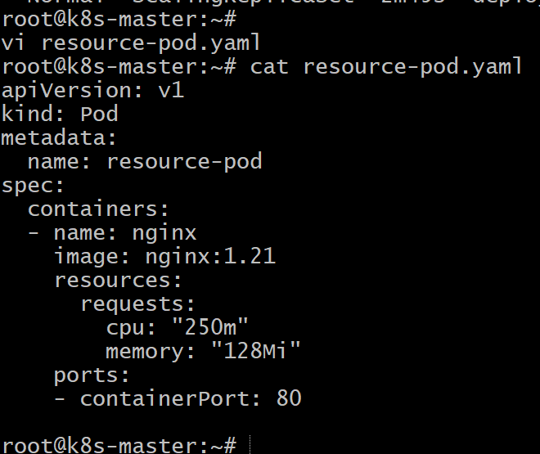
Step 2: Create the Pod
kubectl apply -f resource-pod.yaml
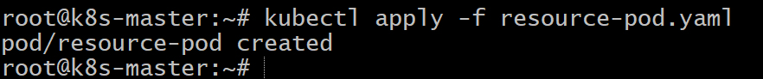

Step 3: Check Pod
kubectl get pods
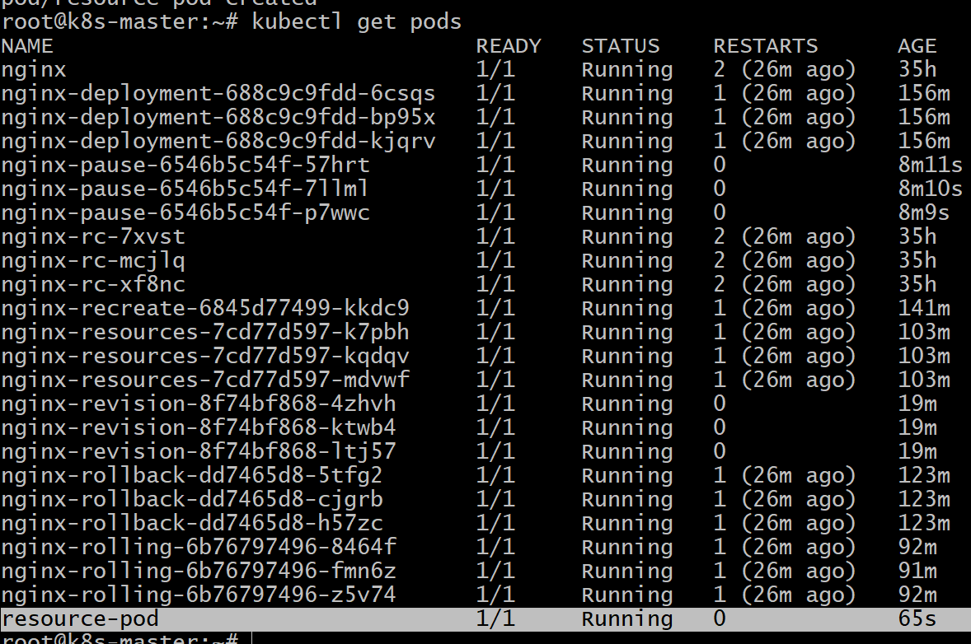
Verification Steps
Check which node scheduled the pod

kubectl get pod resource-pod -o wide
Check scheduler details
kubectl describe pod resource-pod
Look for Node: field showing where the pod was scheduled
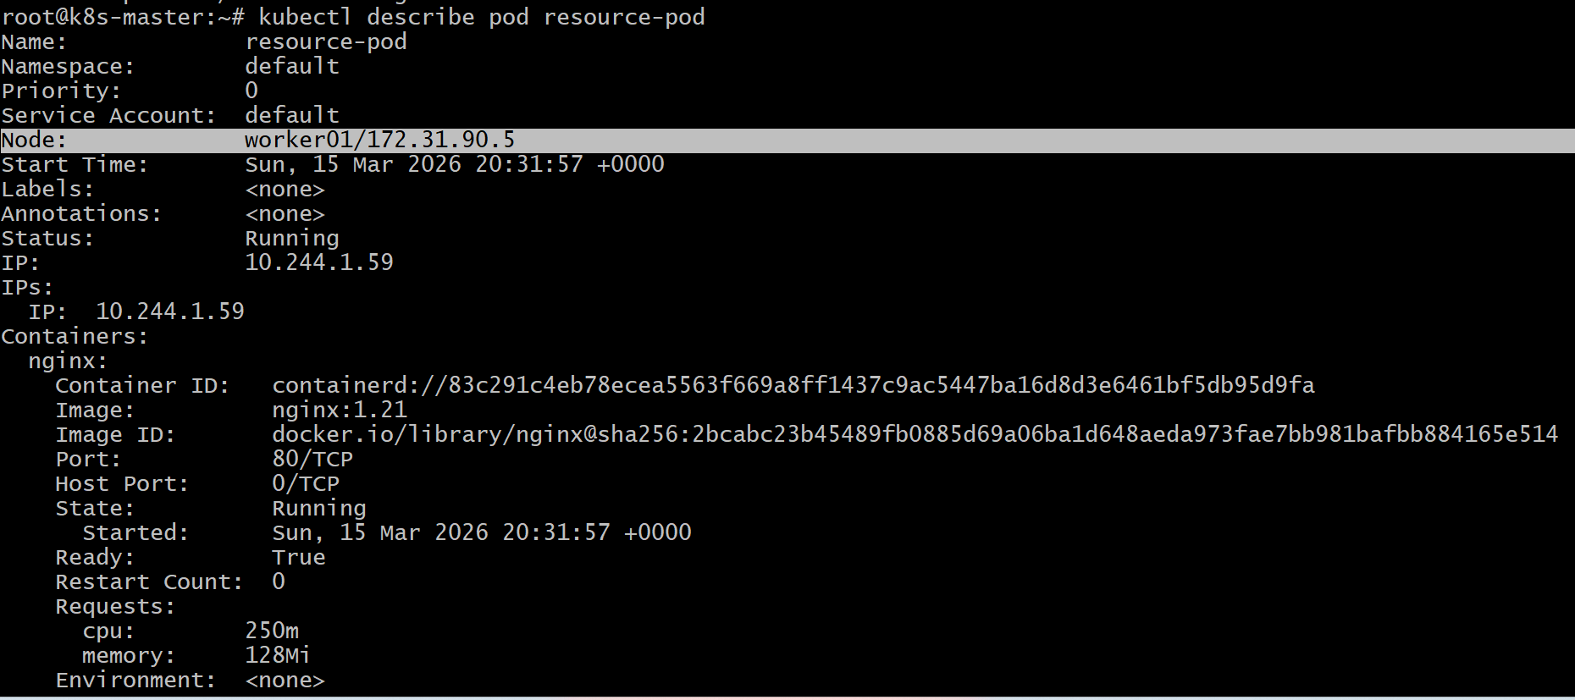
- Conclusion

A pod was created with CPU and memory resource requests.
The Kubernetes scheduler evaluated node resources and assigned the pod to a node that could satisfy the requested CPU and memory requirements.

